Patient Participation Group

Agenda

Date: 12/05/2026
Time: 6pm
Venue: Richmond Medical Centre
Attendees: Dr Cannon (GP Partner), Alice Ross (Practice Manager), Pauline Oldfield (Vice Chairperson), Peter Oldfield, Tony Walker, Nicola Capelin, Anthony Williams, Jennifer Williams
Apologies: Chris Brady, Margaret McIntosh

Apologies:
Items-:
Item | Topic | Action
1 | - Welcome, and introduction to new members. | Participants asked regarding how previous chairperson LL was.  CC wrote to AR today to say that due to a change in family circumstances she is unable to commit the time felt that she should to the PPG, and gave notice to say that she would be unable to attend any further meetings.
2 | Icebreaker Activity- Blob Tree  - Select a ‘blob’ on the tree which represents how you’re feeling today, and why?  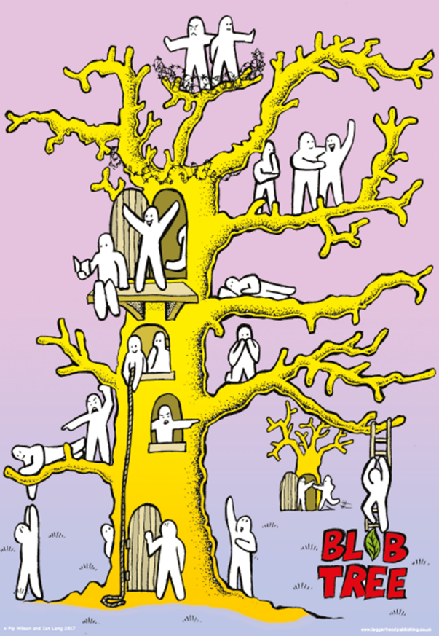 | All participated in the icebreaker challenge, which gave a snapshot insight into participants weeks so far.  It transpired that PO in a previous management role had designed icebreaker challenges and agreed to come up with one for the next meeting.
3 | 3.1 Practice Updates  3.2 New Uniforms  - Our reception team and Health Care Assistants have recently received new uniforms and badges with our Practice logo    - We are looking forward to taking some new photos and updating our team photos for everyone in the corridor.  3.3 Phlebotomy Services  - Dr TC to discuss pressures on phlebotomy appointments in practice  - Options for patients who are able, to attend the drive through clinic.  3.4 New visitor signing in and out system  - Feedback on the QR code process for visitors signing in and out | 3.1 currently working on strengthening relationships within the community and have recently re-engaged with the District Nursing team, who are attending monthly practice meetings to discuss ongoing patient care.  3.2 noted  3.3 Phlebotomy Services  Appointments are scarce for blood appts encouraging ppl to use the drop in and drive through clinics at the Hallamshire.  3.4 PPG members weren’t asked to use the sign in system, so one to trial for next time.
4 | 4.1 Meet the Team  A section to showcase members of the practice team.  Lisa Lowe  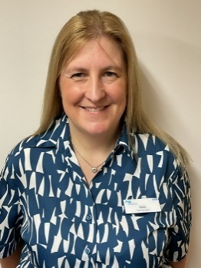  - What’s your role here/ how long have you been here?  Receptionist/ Care Navigator- 5 weeks  - How long have you worked in healthcare?  22 years  - What do you enjoy most about helping patients?  Being able to make a difference to someone’s day  - What’s your favourite way to spend a day off?  Going out with the family (husband and 2 kids)  - What’s a hobby you love outside of work?  Doing anything creative  - Do you have any pets?  2 cats, Meeko and Simba  - What’s your favourite cake?  Victoria sponge or carrot cake  - What’s your favourite holiday destination?  Anywhere hot!  - Early bird or night owl?  Both  - What’s a fun fact about you?  I used to work in a vets  - What is your favourite thing about working at Richmond Medical Centre?  The staff- they have all been very helpful and made me feel welcome  Lauren Spencer  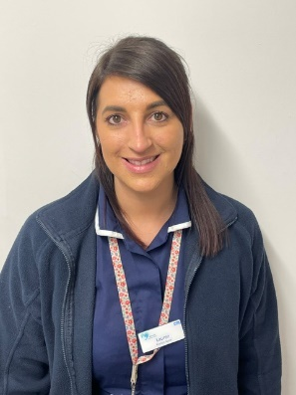  - What’s your role here/ how long have you been here?  Practice Nurse- 2 months  - How long have you worked in healthcare?  13 years  - What do you enjoy most about helping patients?  Making a difference, providing care with compassion and respect  - What’s your favourite way to spend a day off?  With my children/ family  - What’s a hobby you love outside of work?  Camping with family and friends  - Do you have any pets?  no  - What’s your favourite cake?  Red velvet  - What’s your favourite holiday destination?  Thailand  - Early bird or night owl?  Night owl  - What’s a fun fact about you?  I am a pineapple on pizza girl  - What is your favourite thing about working at Richmond Medical Centre?  Friendly staff
5 | 5.1 Primary Care network (PCN)  Townships 2 PCN  - New Manager has started, John White who has had experience running PCN’s in Derbyshire.  5.2 Social Prescribing team  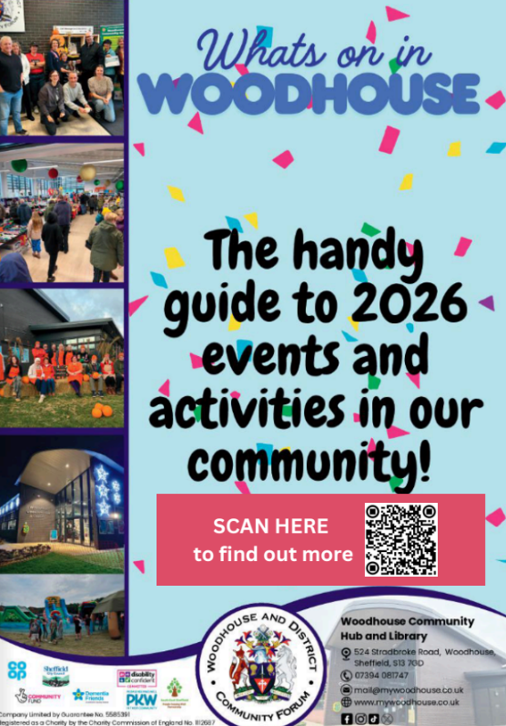 | 5.1 Discussion around Primary Care Networks and their role within the locality and for our practice such as shared clinical roles between practices, the operation of the out of hours hub from Woodhouse surgery, and shared funding for community projects.  Other practices within our PCN network are Stonecroft Medical Centre, Jaunty Springs Health Centre, Charnock Health Primary Care Centre and Woodhouse Medical Practice.  It was asked whether Sheffield alarm system was something which was run by our PCN. This is actually something which is run Sheffield wide.  5.2 Update regarding social prescribing and a team which works within our PCN who help direct patients to things happening in the locality.  What’s on in Woodhouse is a digital magazine of events, clubs and classes being hosted in the locality.
6 | 6.1 PPG Board in Reception  - Feedback on the board  6.2 Children’s Book Swap area  - Looked into this following the last meeting to make sure that this is something we were able to have from a CQC compliance perspective.  - Have created a policy and we are able to have as long as we only-:  - accept books in good condition  - they are checked regularly  - we have a sanitising station  - Does anyone perhaps have a bookshelf they would like to donate, or know where we may be able to get one from?  - A patient made a suggestion that we could have an poster in this area advertising that if patients wanted to donate any toys, then they could be taken to the local women’s shelter as they are always looking for donations. | 6.1 Good, bright and eye catching.  6.2 It was raised that children could pick up a disease from the book swap area. It was a clinical risk we had considered, however it was deemed that young children sat looking at phones posed more of a long term health risk. Children could catch things from anything they touch, which we have no control over.  We have looked into CQC guidelines (care quality commission), to check that we could make this area compliant and we have completed an associated policy.  It was suggested that as well as books, we could also have coloring sheets- photocopied, with clipboards and crayons for children as this is something which has been seen at Woodhouse library and is effective.  It was discussed that a trolley – with sections may be more effective for the area as it can be wheeled out of the way if needed. It was suggested that this area could be at the end of the waiting room near the window so as hopefully not to be in other patients’ way.  Collect and donate- toys for the refuge would need to be collected by the practice who could then deliver the donations as their locations are protected.
7 | 7.1 PPG Questionnaire  Proposed questionnaire to look through and agree questions. | 7.1 A proposed questionnaire was looked through by the group.  A suggestion was made to put the summary question at the end.  It was suggested that ‘after all the points so far, how would you rate the practice’ is included as a question.  It was agreed that there should always be an ‘other’ option to answer questions.  It was queried what were we going to do with the answers to the questionnaire.  HC has vast experience in producing questionnaire’s and agreed to take on the project of tweaking and enhancing the questionnaire, as well as mocking up potential answers to check the patient flow of the questionnaire.  AR to email HC a copy of the questionnaire template so far.  It was asked whether there any questions anyone thinks that should have been asked that isn’t on the questionnaire? Noone could think of anything at that time, but were encouraged to message HC if they thought of anything.  Patient feedback- The PPG said that they don’t get any from practice > patients  They sometimes find information on other facebook/ S13 sites, and through outreach MS group.  The practice don’t currently have a Facebook page but AR raised that maybe we could signpost patients to the PCN’s Facebook page with locality information.  The PPG asked whether there could be on the day bulk text messages to patients when something has happened. AR said that unfortunately there is a cost associated with bulk text messaging, so is not something we can rely on.  Suggested that when we send text messages to patients, we also say-:  “Please check our website for more practice info” when sending text messages with link to the website, as patients aren’t aware that there is other information there than just contact details.
8 | 8.1 Practice Improvements  8.2 Accessibility (HC)  Have included extra signage for disabled bays in the car park.  8.3 Improving Practice Nonattendance  Have taken on board discussions from last months meeting and we now include a cancellation link when sending out reminders to patients of appointments. | 8.1 In the previous meeting it was mentioned that we would be looking to take on an additional Doctor and it was asked whether this had happened yet.  Unfortunately, at this time we are still waiting for funding to become available before we are able to recruit the position. It is however something which we are very much still planning to do.  8.2 noted  8.3 noted
9 | Any other business | Discussion around patients who are queuing at 8am. Could there be a triage nurse checking through ppl- lots of ppl don’t need to be seen by a doctor, which could open up more appts?  Dr TC says that triaging could double up on time taken as a brief description would be taken and looked into initially, but would then need going through again when subsequently seeing a doctor.  It was asked that if a doctor asks to see you the following week then you should be able to make the appointment and that there should be more uniformity in how we practice. A member of the PPG reported that they had experienced multiple instances of this where they had been asked to make a follow up appt by the GP, only to be told that when going to reception that they couldn’t have the appointment. It was agreed from a practice perspective that this wasn’t acceptable.  Dr TC said that if he wanted a patient to come back for a follow up appointment, he would make that appointment then and there with the patient.  Other PPG members reported that Dr HM has also done this.  It was agreed as a practice that this would be taken to our clinical meeting to discuss with clinicians and to get consensus on how we process follow up appointments.  HC asked about drug trials and reported that at 65 you are excluded from taking part in this. He queried that surely patients of all ages need to be tested on drugs. DR Dr TC said that unfortunately we don’t take part in drug trials and couldn’t comment on this.
10 | Action points and next steps | PO icebreaker  HC questionnaire  AR Childrens area
11 | Date of next meeting | Tuesday 14th July- 6pm

